**Eaton Guide Specification**

**Notes and instructions to specwriter**

The following guide specification is offered for your assistance in specifying this product as part of a CSI (Construction Specification Institute) compliant document.

This guide specification has been created in MS Word and uses Word features including **Styles** and **Review** to assist in editing and formatting. You may also find it helpful to view the document in **Outline** mode when editing or selecting sections to copy/paste into your base document.

**Styles**

Styles are provided for all paragraph types described in the CSI Masterformat. Applying a Style to text will provide the correct indentation, paragraph letter/number, font, capitalization, etc…. Styles are shown on the right-hand side of the Word “Home” ribbon.



**Review**

“Notes to Specwriter” (when available) are provided using the Reviews feature in Word. To view “Notes to Specwriter” select “All Markup” in the Tracking dropdown menu on the Review ribbon. To hide notes, select “No Markup”. You can advance from one note to the next using the Previous and Next buttons on the same ribbon. In earlier versions of MSWord hide notes by un-checking ‘Comments’ under Review>SH

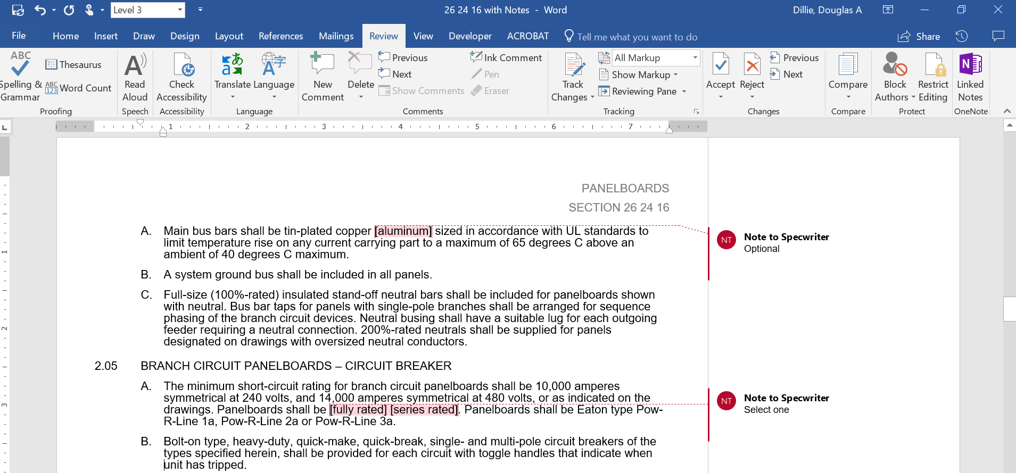

**Outline view**

The Outline view within Word is often helpful when editing or copying sections from this Guide Specification. Also, when pasting sections from this document into a base document the specwriter may want to consider using right-click and “Merge Formatting’ or ‘Keep Text Only” features.

Section 26 13 19 04

Medium voltage Padmount switchgear

# General

## Scope

### This specification applies to three-phase, [50 Hz] [60 Hz] [___] - way [___] - source, [___] -tap vacuum fault interrupters with up to [17.5 kV, 95 kV-BIL] [27 kV, 12595 kV-BIL.

### This specification shall only cover the purchase and shipment of medium voltage vacuum fault interrupters. The purchaser and/or user shall be responsible for all site-work, electrical connections, and installation.

## References

### The medium voltage switchgear and all components shall be designed, manufactured and tested in accordance with the latest applicable standards as follows:

#### IEEE Std C37.74™ standard – Subsurface, Vault, and Pad-Mounted Load-Interrupter Switchgear up to 39 kV

#### IEEE Std C57.12.28-2005 standard – Standard for Pad-Mounted Equipment - Enclosure Integrity.

#### IEEE Std C57.12.29 – IEEE Standard for Pad-Mounted Equipment-Enclosure Integrity for Coastal Environments

#### IEEE Std 386™ standard – Separable Insulated Connector Systems for Distribution Systems above 600 V

#### IEEE Std C37.04™ standard – Rating Structure for AC High-Voltage Circuit Breakers

#### IEEE Std C37.09™ standard – Test Procedure for AC High-Voltage Circuit Breakers

#### IEEE Std C57.12.40™ standard – Standard for Secondary Network Transformer (Ground Switch)

# Products

## APPROVED MANUFACTURERS

### Eaton

## Ratings

### This specification is for three-phase, [50 Hz] [60 Hz] MV air insulated, vacuum fault interrupters rated as follows:

#### Nominal System Operating Voltage (kV) __________ [27 kV Maximum]

#### Maximum System Operating Voltage (kV) __________ [27 kV Maximum]

#### Basic Insulation Level (BIL) __________ [125 kV Maximum]

#### Continuous Current Rating (A) __________ [200A, 600A, 900A, 1200A]

#### Mechanical Operations Endurance 10,000

#### Three-phase Short Circuit Rating (kA) __________ [@ 17.5 kV 25kA sym or 40kA sym max, @ 27 kV 31.5 kA max]

#### Line-to-ground Short Circuit Rating (kA) __________ [@ 17.5 kV 25kA sym or 40kA sym max, @ 27 kV 31.5 kA max]

#### Momentary Withstand (asym) __________ [@ 17.5 kV 65kA or 104kA max, @ 27 kV 82 kA max]

#### Altitude above Sea Level (m) __________

#### Minimum Ambient Temperature (°C) __________

#### Maximum Ambient Temperature (°C) __________

#### Seismic Level per IEEE Std 693™ __________ [Low, Moderate, High]

## Construction

### The manufacturer of the MV three-phase vacuum fault interrupter shall also be the designer and manufacturer of the vacuum bottle and interrupting mechanism to ensure the highest quality and one-point of responsibility for the integration of the key components.

### [The padmount distribution switchgear shall consist of a 2-sided, sealed insulation tank. Switchgear shall have front accessible control with manual integral push button operating provisions and rear mounted terminations suitable for cables entering from below. Overall height, width, depth and layout shall conform to the manufacturer’s standard construction practices for the configuration, ratings, and voltage class specified. Standard construction shall be of [mild steel with stainless steel hardware] [100% 304L stainless steel] [316 stainless steel].

### [The padmount distribution switchgear shall consist of a 2-sided, sealed insulation tank. Switchgear shall have front and rear accessible controls with manual integral push button operating provisions, and cable terminations suitable for cables entering from below. Overall height, width, depth and layout shall conform to the manufacturer’s standard construction practices for the configuration, ratings, and voltage class specified. Standard construction shall be of [mild steel with stainless steel hardware] [100% 304L stainless steel] [316 stainless steel].

### [The padmount distribution switchgear shall consist of a 1-sided, sealed insulation tank. Switchgear shall have front accessible controls with manual integral push button operating provisions, and cable terminations suitable for cables entering from below. Overall height, width, depth and layout shall conform to the manufacturer’s standard construction practices for the configuration, ratings, and voltage class specified. Standard construction shall be of [mild steel with stainless steel hardware] [100% 304L stainless steel] [316 stainless steel].

### No gas or oil

### Cable compartments shall both have a minimum depth of 18.5 inches to provide ease of cable installation and allow for the addition of termination accessories.

### Internal bussing to consist of fluidized epoxy coated copper insulated bus

### The enclosure shall be finished in [Guardian Green (Munsell 7.0GY3.29/1.5)] [ANSI 61 Grey (Munsell 8.3G 6.10/0.54)] [ANSI 70 Grey (Munsell 5BG 7.0/0.4)] [custom color].

### The coating shall meet all requirements of [IEEE Std C57.12.28-2005 standard – Standard for Pad-Mounted Equipment - Enclosure Integrity] [IEEE Std C57.12.29 – IEEE Standard for Pad-Mounted Equipment-Enclosure Integrity for Coastal Environments].

### The equipment incoming compartment shall be [live front] [dead front]

### Stainless steel nameplate containing the following information:

#### Manufacturer

#### Weight

#### Serial Number

#### Date of Assembly

#### Rated Maximum Operating Voltage

#### Rated Frequency

#### Rated Continuous Current Rating

#### Rated max Interrupting Rating

#### Rated Basic Insulation Level (BIL)

### The metal corrosion-resistant nameplate shall be affixed by corrosion-resistant screws or suitable adhesive to stick to the vacuum interrupter enclosure.

### A non-resettable operation counter shall be provided.

### A mechanical indicator shall be provided that will indicate the OPEN and CLOSE positions of the vacuum interrupter. When the vacuum interrupter is fully open, only the word OPEN shall be visible. When the vacuum interrupter is fully closed, only the word CLOSE shall be visible. A mechanical indicator will also be provided for the state of the charging springs for the stored energy operator.

### Side-hinged cabinet style doors shall be provided. The side-hinged doors shall provide three-point latching. Side-hinged doors shall have a door stay to manually latch the door in the open position at not less than 90º from the closed position. The right hand door on each side shall be the first opening door and shall be secured with a recessed stainless steel pentahead bolt, with provisions for padlocking. Cabinet construction shall meet all NEMA and ANSI security requirements as defined in the IEEE Std C57.12.28™-2005 standard and the construction requirements of the IEEE Std C37.74™-2003 standard.

### The enclosure shall each include four steel lifting eyes with a minimum inside diameter of 25 mm (1.0 in) and shall be located on opposite sides of the unit, in a vertical plane approximately through the center of gravity.

### Enclosure-grounding provisions shall consist of a copper-faced-steel or stainless-steel pad with two holes horizontally spaced on 44.5 mm (1-3/4 in) centers and drilled and tapped for 1/2-13 UNC thread (refer to ASME B1.1 [B3]). The ground pad shall be welded to the enclosure. The minimum thickness of the facing shall be 0.38 mm (0.015 in). The minimum threaded depth of holes shall be 12.7 mm (0.5 in). Thread protection for the ground pad shall be provided.

### Bushings shall be deadfront type for use with separable connectors conforming to IEEE Std 386™-2006 standard and ANSI Standard C119.2. The source and tap ways shall have a continuous current rating of 600 ampere with bushings.

### 600 ampere bushings shall be horizontally configured at minimum of 25 inches above the pad and accept molded, separable deadfront connectors. Bushings shall be mounted with minimum spacing of 7.0-inches between centerlines. A standoff bracket or parking stand shall be supplied for each bushing and shall be mounted below each bushing. The standard phasing from left to right shall follow the sequence ABC (single-sided designs only). Each bushing shall have identification affixed to the front plate identifying its source or tap designation, as shown on the one-line operating diagram, and its phase identification.

### Source switches shall consist of 3 phase molded-case vacuum switches equipped with a stored energy spring operating mechanism. When springs are fully charged switch is capable of an O-C-O operation. Switch to be supplied with integral open/close pushbutton control. Switch to include integral manual charging handle to allow recharging the stored energy mechanism if power is lost and springs are discharged. Pushbutton operators shall be front plate mounted and shall be pad-lockable to prevent CLOSE access.

### The switchgear shall incorporate 3 phase gang-operated molded-case vacuum fault interrupters for tap overcurrent protection. The device shall interrupt all fault currents up to its maximum rated current of [25,000] [31500] [40,000] RMS amperes symmetrical. The interrupter shall be manually resettable, with no consumable parts (i.e. fuses). The maximum interrupting time from issuance of a trip signal from the electronic control shall be 3 cycles. Vacuum fault interrupters shall be equipped with a stored energy spring operating mechanism. When springs are fully charged interrupter is capable of an O-C-O operation. Switch to be supplied with integral open/close pushbutton control. Switch to include integral manual charging handle to allow recharging the stored energy mechanism if power is lost and springs are discharged. Pushbutton operators shall be front plate mounted and shall be pad-lockable to prevent CLOSE access.

## Three-Pole Isolation Switch Option

### A three-pole, manually group-operated, non-load break, air insulated, isolation switch shall be included internal to the enclosure and will provide a visible disconnect between the load- and source-side bushings.

### One viewing window installed on the front of the enclosure shall be provided to clearly show that the bus of all three phases have separated which will serve as a visible break. A viewing window shall also be provided that clearly shows the position of the isolation switch.

### The isolation switch shall be mechanically interlocked with the vacuum interrupting load-break mechanism to prevent operating the isolation switch while the vacuum interrupting load-break mechanism is closed

### The isolation switch shall be mechanically interlocked with the grounding switch to prevent the grounding switch from being operated while the isolation switch is in the CLOSED position.

## Three-Pole Grounding SWITCH OPTION

### A three-pole grounding switch shall be provided for grounding the bus electrically tied to the bushings and shall be located internal to the switch enclosure. A ground switch with a fully insulated manually operating handle shall be provided for safety and visual ground indication. Remote operation not permitted.

### One viewing window installed on the front of the enclosure shall be provided to clearly show that the grounding bus has made contact with all three phases electrically tied to the bushings. A viewing window shall also be provided that clearly shows what position the grounding switch is in.

### The grounding switch shall be equipped with mechanical interlocks to prevent operation of the grounding switch while the visible isolation switch is in the CLOSED position.

### The grounding switch shall be rated to withstand 15kA for 5s and 45kA for 0.2s when in the ground position.

## Low-Voltage Wiring

### The low-voltage control wiring shall be completely self-contained within the enclosure unless otherwise noted in this specification

### Control wiring will be accessible through a gasketed door or access panel.

### All external control power will be provided by the end user; the MV Vacuum interrupter shall be rated for

### Control Operating Voltage shall be [VDC - 24, 48, 110,125] [VAC - 120, 220, 240]

## Protection and Control

### The primary vacuum interrupter shall be equipped with a Digitrip 1150 V controller (15 kV only) capable of providing over-current protection, metering and communications functionality. The Digitrip shall be mounted integral to the vacuum fault interrupter.

### Current sensors shall be provided and mounted internal to the enclosure. The current sensor secondaries shall be wired internally and rated accordingly to match the rating of the vacuum interrupter and coordinate with the controller.

### A communication module shall be provided to interface with the Digitrip 1150 V (15 kV only) allowing for seamless integration with upstream communication devices. The communication module will allow the user through a secure interface to view and change Digitrip settings via a personal laptop.

### Control shall be [specify relay]

## Options

### Control power transformer shall be provided and mounted internally to the switchgear connected [L-G] [L-L]. The CPT will be connected to the common bus of the switchgear.

### Auxiliary switches

### PT and fuses will be included to provide voltage sensing. PTs will be connected [(3) L-G] [(2) Open-delta] and accessible through a gasketed door or access panel.

# Execution

## Testing

### The manufacturer shall test all wiring for grounds, opens and proper continuity, and for proper operation of all controls, contacts, switches, mechanisms and interlocks.

### Type test reports shall be available upon request by the end user.

## Quality Assurance

### The manufacturer shall be a global leader in vacuum interrupter solutions.

### Equipment shall be built in accordance with the industry standards for medium voltage equipment.

### The manufacturer shall be registered and certified as ISO 9001 compliant by a recognized international and independent body.

### Manufacturer warranty should include a minimum of 12 months from date of energization, not to exceed 18 months from ship date