
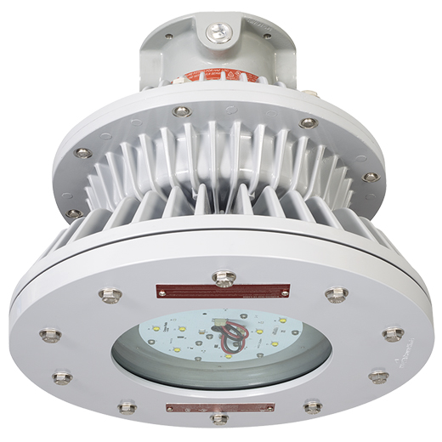

Product Specification Sheet

PRODUCT NAME: Hazard•Gard® EVLL
PRODUCT SPECIFICATIONS: Specifications unique to Eaton Crouse-Hinds are highlighted in yellow

Electrical Requirements
- Standard input driver voltage
  - 100-277 VAC, 50/60 Hz and 108-250VDC 50/60 Hz
  - 347-480 VAC, 50/60 Hz
- <90% power factor
- System Efficiency: Minimum of 90 LPW for all fixtures
- 2 voltage surge protection built into the drivers
- Maximum desired input power (wattage) and current (amps) by fixture type:
Lumen Output | Wattage | Amperes @ 100-277VAC | Amperes @ 108-250VDC
5,735 Lumens | 56W | 0.47-0.21 | 0.53-0.23
8,293 Lumens | 85W | 0.72-0.32 | 0.81-0.35
10,313 Lumens | 115W | 0.96-0.42 | 1.08-0.46
10,997 Lumens | 112W | 0.94-0.41 | 1.07-0.45
13,598 Lumens | 149W | 1.25-0.54 | 1.43-0.60

Material Requirements
- LED Housing assembly and mounting modules must be of die cast aluminum with Corro-free™ epoxy powder coat for corrosion protection and heat dissipation
- LED board assembly lens cover must be made of heat and impact resistant glass
- Shatter resistant explosion proof glass lens must be provided for reliable and safe operation
- Fixtures must not contain mercury or any other hazardous chemicals
- The fixture shall have external surface of copper free anodized aluminum and silicon type gaskets between the lens and LED board assembly, driver and LED housing for protection against acids (including acetic acid), sulfur, water (liquid and vapor form), dust, hydrocarbons and chlorine

Certification & Compliance Requirements
- The luminaire shall meet the following NEC/CEC certifications:
  - Class I, Division 1, Groups B, C, D
  - Class II, Groups E, F, G
  - Class III, Simultaneous Presence
UL Standards
  - UL844 Electric Fixture Hangers for Hazardous Locations
  - UL1598 Luminaires
  - UL1598A Luminaire for Installation on Marine Vessels
CSA Standard
  - CSA C22.2 No. 137
Environmental Ratings
  - NEMA 4X
  - IP66
  - Marine and Wet Locations

- The luminaire shall meet the following IEC/ATEX certifications:
  - Ex II 2G Ex d IIC (Zone 1, 2)
  - Ex II 2D Ex tD A21 IP66 (Zone 21, 22)

- Fixtures need to have a startup and operating ambient temperature range of -25c to +65C for models 5L-9L, -25c to +55c for 11L & 13L.
  - T5 temperature rating @ 55C & 65C ambient for CI,II, Div I&II and simultaneous presence environment
  - T6 temperature rating @ 55C for CI DivI environments

- Water shall not enter the compartment that houses wiring, wiring devices, or lamps under any condition of exposure other than submersion

- The fixture shall successfully be tested for 3 axis (8G) vibration testing to withstand extreme vibration prone environments

LED System & Optics
- LED fixtures must have Correlated Color Temperature of 5000K or 3000K
- The fixtures shall use Lumileds surface mount LEDs with a Color Rendering Index (CRI) of minimum of 70 @ 5000K and 80 @ 3000K.
- The fixture should have lumen output of a minimum of 13000 lumens for mounting heights of 20-25ft to replace a 400w HID equivalent.
- The LED fixtures must be rated for 60,000 hrs of life with no less than 70% lumen degradation for ambient operating temperature range of -25C to +65C (5L-9L) and -25c to +55c (11L & 13L).
- External power supply drivers must be utilized with a minimum of 3” separation from LED PCB circuit for effective heat dissipation and increased reliability
- Fixtures must have redundant drivers so that loss of an individual driver does not cause loss of illumination and downtime. (Only 5L does not have multiple drivers.)

Design and Operational Requirements
- Factory sealed construction with no external sealing fittings required for Groups B, C, and D
- The LED housing should have an efficient thermal and flame paths to the heat sink assembly to ensure operating temperatures of up to 65C
- The design shall have serviceable drivers and LED subassemblies. Every effort to make these components accessible and serviceable as quickly and easily as possible must be taken.
- Shock and vibration resistant construction with no filaments or glass components than can break or shatter
- Photocell option for automatic dusk to dawn lighting to enable additional energy savings while maintaining consistent work area light levels
  - Factory sealed explosion proof Class I Div 2 enclosure with UL 844 hazardous location certification
  - Operating voltage range of 120-277v and in ambient temperature of upto 65 degC

Installation
- Fixtures must be able to retrofit to CCH Hazard•Gard® Series EVLS, EVM and EVLP HID luminaires using the same mounting modules
- The fixtures must be able to connect directly to the existing CCH Hazard-Gard series mounting modules using quick connect wirefree feature for fast and easy installation
- For new construction, only the mounting module should require wiring. Once installed the LED and driver house should screw in to the mounting module using two start ACME threads and quick connect wireless connections
- Provision of an adaptor (CCH EVSA type) with quick-connect wirefree design for installing LED and driver housing to those mounting modules (eg: CCH EVM, EVI and EVLP mounting modules) which cannot be directly retrofitted with LED housing and driver assembly.
- The following mounting modules should be available
  - 3⁄4” NPT (Pendant, Ceiling, and Wall Only)
  - 1” NPT (Pendant, Ceiling, and Wall Only)
  - 1 _{1⁄2}” NPT (Stanchion Only)
  - 25 mm (Pendant, Ceiling, and Wall Only)
  - 32 mm (Pendant, Ceiling, and Wall Only)
  - Trunnion mount with 0°, 22.5° and 45° angles. The Trunnion should not be adjustable to an angle greater than ±90° to meet temperature requirements.

